**Regular Monthly Meeting Date**

3rd Monday

7:00 p.m.

**Find Meeting Agendas and Minutes in the Member’s Section of our Website**

[**www.florencefop33.org**](http://www.florencefop33.org)

On December 21, 2020 the biennial executive board elections were held. The new Executive Board members will be sworn in at the meeting on January 18th. Congratulations to the new E-board.

President: Chris McGreevy  
1st Vice President: Ethan Manley  
2nd Vice President: Nick Houlehan  
Secretary: Sandra Deleon  
Treasurer: Zac Eagler  
Sgt. At Arms: Tad Ecklar  
Chaplain: Mike Stanaland  
State Trustee: Rob Fulton  
Immediate Past President: Kevin Duncan

# Executive Board Election



[This Photo](http://www.hcpl.net/content/library-closing-dates-and-time-changes-holidays) by Unknown Author is licensed under [CC BY-SA-NC](https://creativecommons.org/licenses/by-nc-sa/3.0/)

12/22/20

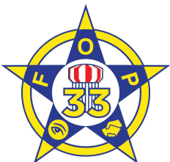

Inside This Issue

1. Welcome

1 Executive Board Election

2 Thanksgiving Meal Delivery

2 Cops and Kids

3 FOP Associate Lodge

4 FOP Benefits Spotlight

4 Upcoming Events

# 2020 Coming to an End….. Finally

Welcome to the second issue of the FOP Lodge 33 newsletter. It is no doubt that 2020 has been like no other, but despite the COVID restrictions, business shut downs, and isolation, members of Lodge 33 have continued to show up and support the community when there was a need day in and day out.

Despite the difficulties of this year, we were able to carry out several community events, and the regular business of the lodge. Thank you to our members and supporters for making 2020 the best it could be under the circumstances, and on behalf of the Executive Board for Lodge 33, we hope everyone has a safe, happy and healthy Holiday Season and a Happy New Year!

Florence

FOP Lodge #33 Newsletter

volume 1 issue 2



<http://www.florencefop33.org/blog/cops-kids-2020/>  
  
COVID-19 did not keep Florence FOP 33 members from our annual Cops and Kids festivities, though they looked quite a bit different this year. Lodge 33 members, with the assistance of the Family Resource Centers at each publicelementary school in Florence, identified families in need of some additional Christmas help and gathered shopping lists for the families. Our members then shopped in small groups, without the kids present this year to keep everyone safe and healthy. The gifts were wrapped with care before being delivered to the family’s homes with several mini police parades.

Along with the gifts provided by a very generous donation from [Meijer](https://www.facebook.com/meijer) in Florence, breakfast biscuits compliments of [Chick-Fil-A Mall Road](https://www.facebook.com/cfamallroad) in Florence were also handed out. We would also like to thank the NKY Keepsake Collectors Club for their generous donation in support of the event.

See photos of the event here: [FOP Shared Folder](https://www.dropbox.com/sh/zy8feys1aqt42gp/AAC7IUcWNh64Gwb9YuecZV6Aa?dl=0)

# Cops and Kids 2020

<http://www.florencefop33.org/blog/fop-lodges-33-and-55-provide-thanksgiving-meals/>   
  
Florence Lodge 33 teamed up with Erlanger/Elsmere Lodge 55 to provide local families with Thanksgiving meal. Thanks to the support of several businesses, including Walmart and The Honey Baked Ham Company, 20 families received full Thanksgiving meals at no cost. Lodge members collected the donations and distributed them to the local families in Boone and Kenton Counties.

Lodge 33 would like to thank these businesses for their support as well as 7 Hills Church, Crossroads Church and Florence United Methodist Church for helping us identify the families in need.

2020 Executive Board

Kevin Duncan, President

Pat Cottingham,   
Vice President

Chris McGreevy,   
2nd Vice President

Zach Eagler, Treasurer/Secretary

Robert Fulton,   
State Trustee

Ethan Manley,   
Sergeant at Arms

Nick Houlehan,  
Chaplain

# Thanksgiving Meal Delivery

**Standing Committees**

Constitution and Bylaws

Elections

Screening Committee

Political Endorsement

Grievance Committee

- If interested in serving on any committee, contact Kevin Duncan or Pat Cottingham

Ladies and Gentleman,

Friends & Family

Subject: FOPA

Good Afternoon, the purpose of my letter is to introduce myself to those of you that don’t know me, my name is Linda Bauerle, and I worked for the Florence Police Dept, for 12 years. Upon my retirement the FOP lodge wanted to see if we could start a FOPA (Fraternal Order of Police Associate}. The FOPA , Lodge 33, is the civilian affiliate of the Fraternal Order of Police (FOP) Lodge 33 in Florence Ky.

Our purpose would be to support legislation, charitable causes, and work with our parent Lodge 33 in any way possible.

This is all so new, a lot of work to do in getting officers assigned, by-laws completed and submitting our application to the state to be accepted.

Attached is an application to be completed and returned as soon as possible. If you are interested in being a part of the FOPA, please return your form to: [linda.bauerle@gmail.com](mailto:linda.bauerle@gmail.com)

Or call me @ 859-802-0296.

Sincerely,

Linda Bauerle

The plans to establish a new Fraternal Order of Police Associates Lodge were delayed due to COVID-19 but are still in the works. Members are encouraged to recruit family, friends and community members who may be interested in becoming an FOP Associate. See the letter from Linda Bauerle below. The application for membership can be found [HERE.](https://www.dropbox.com/sh/ph563f4v2ip04y4/AAAzcfTqF9erHczgkc8dfFw2a?dl=0)

# FOP Associate Lodge

# Upcoming Events

Due to COVID-19, most of our regular events have been cancelled for 2020. We have resumed holding our monthly meetings.

Lodge Work Day  
(Help Paint, Hang TVs, Clean, etc.) January 2021 - TBD

Regular Lodge Meeting January 18, 2021 at 7 p.m.

**Annual Golf Outing** June 11, 2021

[FOPConnect.com](http://www.FOPConnect.com)supports the mission of the FOP Journal, which is to educate, inform and entertain our readers. As a members-only online platform, **FOPConnect.com** allows FOP Journal readers the chance to enjoy an expanded experience of the magazine and further educate themselves on the issues surrounding law enforcement. **FOPConnect.com** also features exclusive content covering new products, equipment and procedures relating to police work, lifestyle issues and much more. There is currently a $1000 Member Sweepstakes. Be sure to register and enter to win.

[**FOPFreeCollege.org**](http://www.FOPFreeCollege.org)[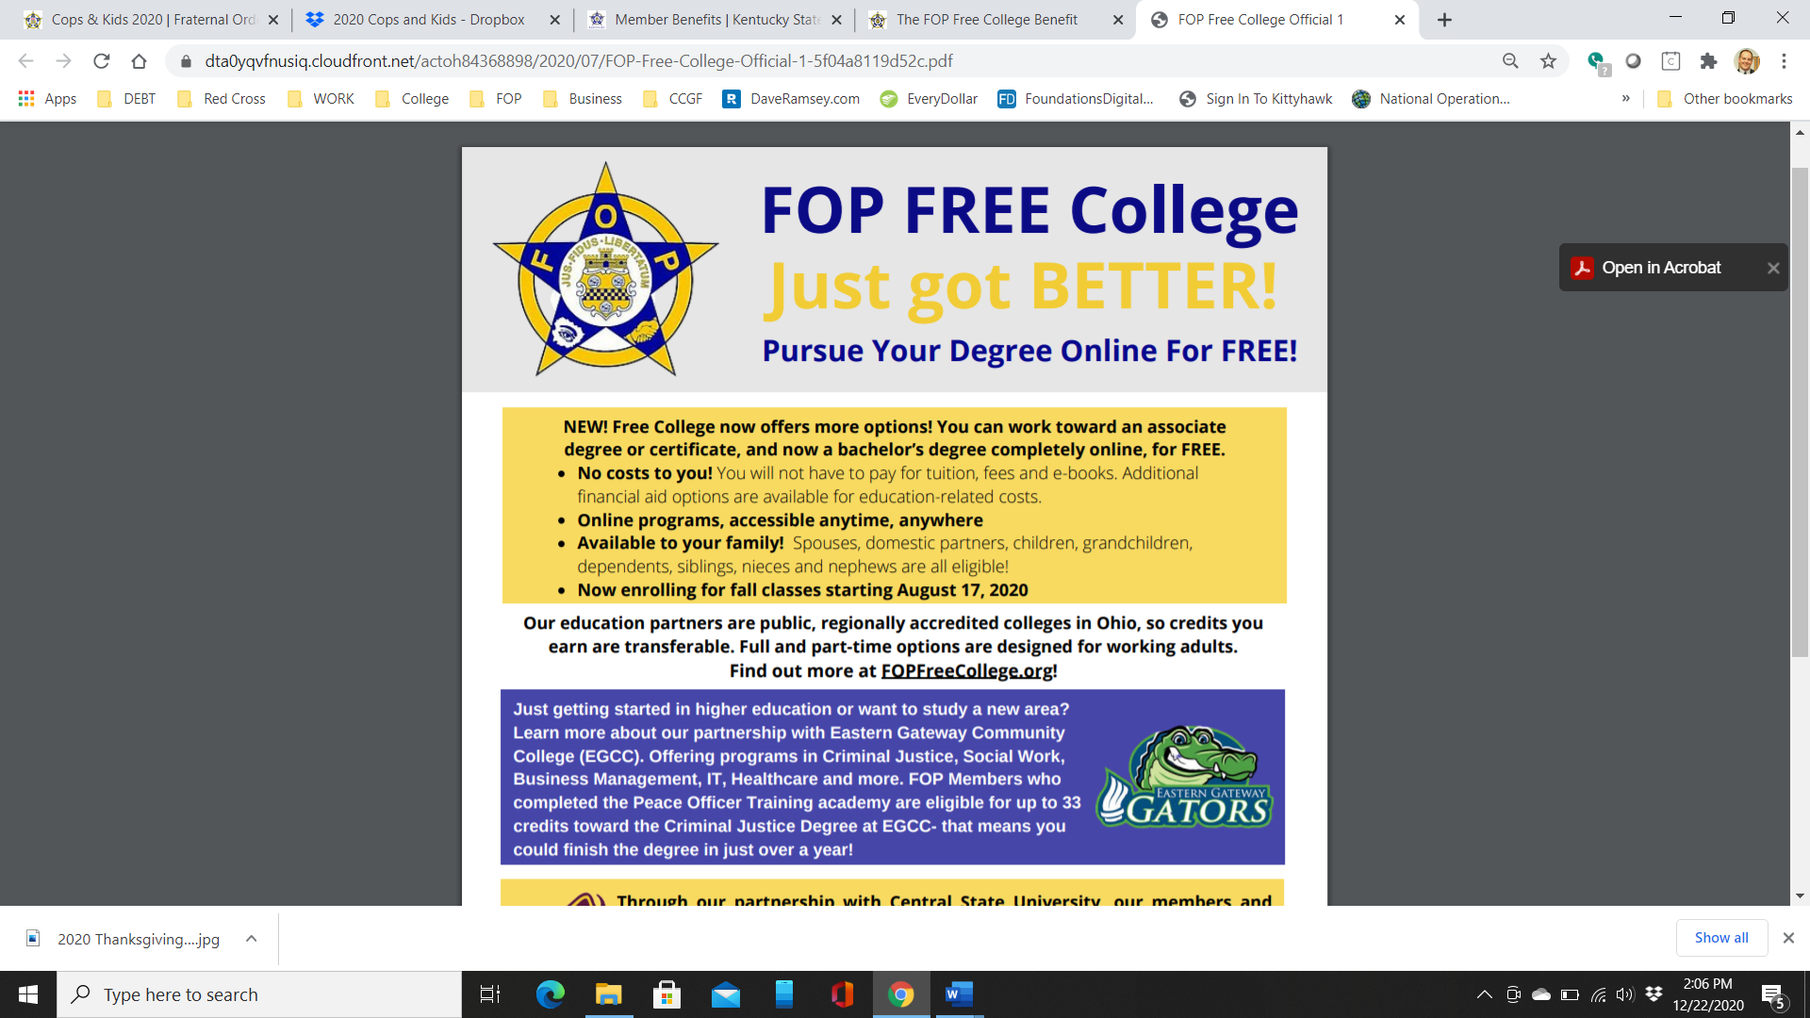](http://www.FOPFreeCollege.org)

# FOP Benefit Spotlight